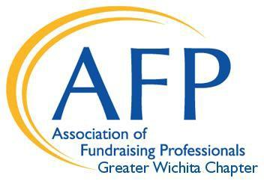

2021 National Philanthropy Day Scholarship
The 2021 National Philanthropy Day will be held November 15, 2021 in Wichita, KS at the Hyatt Regency Hotel. The Greater Wichita Chapter of AFP is offering scholarships to both members and non-members.

The selection criteria include:

- Submit an application for the scholarship by October 15, 2021.
- Agree to serve in some capacity on an AFP committee in the year following the event.

Application Process:

Applicants must submit a completed scholarship application (attached). The application should be sent to the chapter administrator at the address below. The Greater Wichita Chapter Scholarship Committee will screen the applications and reach back out to all applicants.

The deadline to apply is October 15, 2021. ALL APPLICATIONS MUST BE RECEIVED BY THIS DEADLINE. The Chapter will cover the registration cost for members or non-members for the scholarship recipient for both the educational sessions and awards luncheon (educational sessions, members: $40, non-members: $50; awards luncheon: $49).

Submit the completed application via email to:

Bridget Mersmann
Chapter Administrator
AFP Wichita Chapter
afpwichitachapter@gmail.com
316.285.0671
www.afpwichita.com

2021 National Philanthropy Day AFP Greater Wichita Chapter Scholarship Application

Applicant Key Criteria for Consideration:
Submit an application for the scholarship before October 15, 2021.
Agree to serve in some capacity on an AFP planning committee in the year following the event.

Personal Information:

____________________________________________
Name

____________________________________________
Organization

____________________________________________
Title

__________________________________________________
Address

___________________________________________________________________
City State Zip

___________________________________________________________________
Work Phone Cell Phone

_______________________________________________________
Email

_________________________________________
Organization Website Address

Number of Years in the Fundraising Profession:____________

Do you agree to serve in some capacity on an AFP planning committee in the year following the event?

Please explain how you feel attendance at this workshop would benefit you as a fundraising professional.

